

Microsoft Azure Mini Project -by

1)Onkar Jagadale

2)Ravi Adabale

3)Sahara Kharat

Aim: Online Food Ordering System. OFOS is a software system that allows customers to buy food items online. It is Available to anyone with an Internet Connection.

Online Food Ordering Systems allow users to:

1. Order food from a local restaurant or food cooperative
2. View restaurant menus and select desired items
3. Keep accounts to make frequent ordering convenient
4. Place Order via a Website

Overview:

An Online Food Ordering System is a Digital Platform that allows customers to browse menus, and pay for food from restaurants or food establishments through

The internet.These Systems have become Increasingly popular in recent years, especially with the growth of the food delivery industry.Here’s an overview of how an an Online Food Ordering Sysyem Typically Works:

1. **User Registration**: Customers usually start by creating an account or logging in to the platform.They may provide personal information, delivery address, and payment details.
2. **Restaurant Selection**: Customers browse a list of participating restaurant or food providers. They can filter options based on cuisine, location, ratings, and other criteria.
3. **Menu Exploration**: After selecting a restaurant’s menu, which often includes items desriptions, prices, and images.
4. **Order Customisation**: Customers can add items to their virtual shopping cart, customize orders and specify quantities.
5. **Cart Review**: Users review their cart to ensure their order is correct and make adjustments before proceeding to checkout.
6. **Checkout and Payment**: Customers finalise their orders, provide payment information, and select a delivery or pickup option.
7. **Order Confirmation**: Upon successful payments, users receive an order confirmation.

Project Overview Screen Recording Drive Link: <https://drive.google.com/file/d/1jlR7o79IdOiHWy39y0Nr0jqHFiGvQI_W/view?usp=share_link>

Project Resourse Group Template Drive Link: <https://drive.google.com/file/d/1pA7LnN5nDPZW0pLkHRtl3vD_h7svqQQd/view?usp=share_link>

Sevices Used:

1. **Traffic Manager:**

In Microsoft Azure, a Traffic Manager is a service that allows you to distribute traffic across multiple endpoints (such as Azure regions, Azure App Service instances, or external, non-Azure endpoints) based on various routing methods. It is used to improve the availability and responsiveness of your applications by directing user traffic to the most suitable endpoint.

1. **Monitor Alert Rules:**

In Microsoft Azure, a Monitor Alert Rule is a configuration that you can set up to monitor various Azure resources for specific conditions or criteria, and then trigger an action (such as sending an email or running an Azure Function) when those conditions are met. Alert rules are part of Azure Monitor, which is a centralized monitoring and management service for Azure resources.

1. **DNS Zones:**

DNS Zones, in the context of Domain Name System (DNS), refer to distinct areas within the DNS namespace where DNS records are stored and managed. Each DNS zone contains a collection of DNS records that define the mapping between domain names and IP addresses, among other things. DNS Zones are organized hierarchically, and they are crucial for managing the domain name resolution process on the internet

Archietecture:

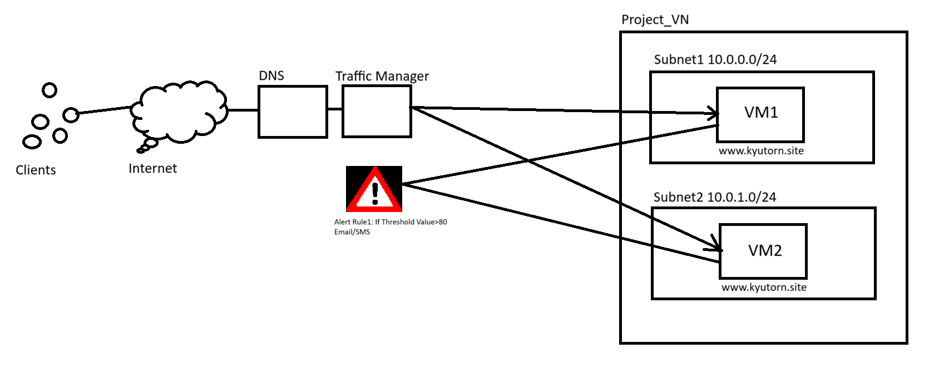

Flow Chart Explaination:

Start

|

|-- Create Azure Virtual Machines (Server1 and Server2)

| |

| |-- Install Apache2 and upload PHP files to Server1

| |

| |-- Install Apache2 and upload PHP files to Server2

| |

| |-- Connect MySQL database to Server1

| |

| |-- Connect MySQL database to Server2

|

|-- Deploy Online Food Ordering System on Server1

|

|-- Deploy Online Food Ordering System on Server2

|

|-- Create Traffic Manager in Azure Portal

| |

| |-- Add Server1 as an Endpoint

| |

| |-- Add Server2 as an Endpoint

|

|-- Set up Monitoring Service Alert Rule

| |

| |-- Define Threshold Condition (e.g., > 80% CPU usage)

| |

| |-- Configure Alert Actions (Email and SMS)

|

|-- Use DNS Zones Service

| |

| |-- Deploy Online Food Ordering System on Server1 using Hostinger

| |

| |-- Activate the DNS Configuration

| |

| |-- Set up CNAME record for "www.kyutorn.site" pointing to Traffic Manager

|

|-- End (Access the website via [www.kyutorn.site](http://www.kyutorn.site))

Step by Step Implementation of Full Project:

Step 1: Create Resourse Group🡪Project_RG

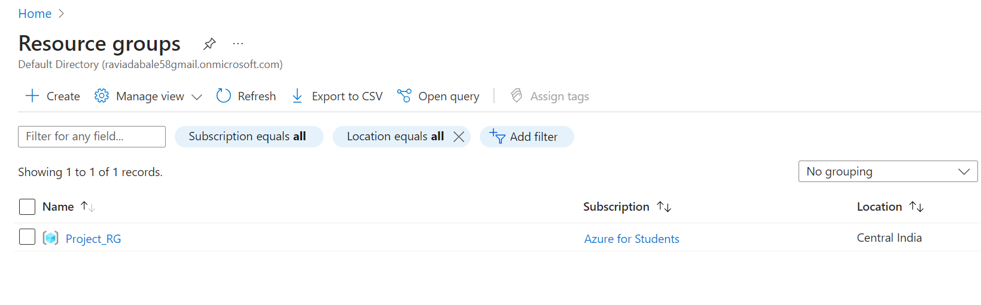

Step 2: Create Virtual Network Project_VN🡪 Region:Central India

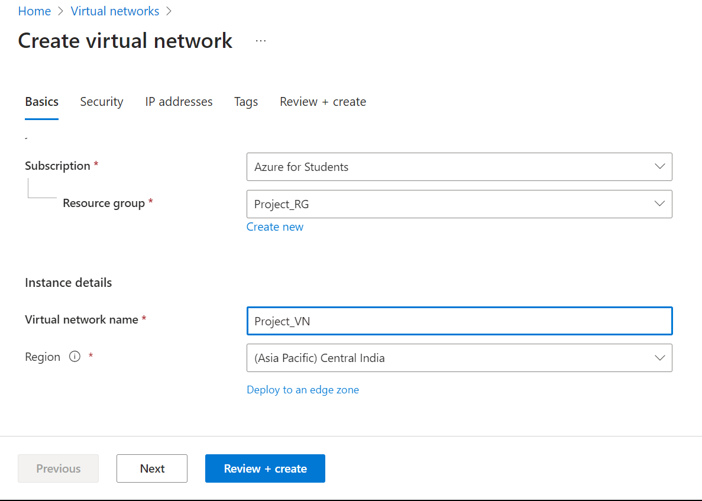

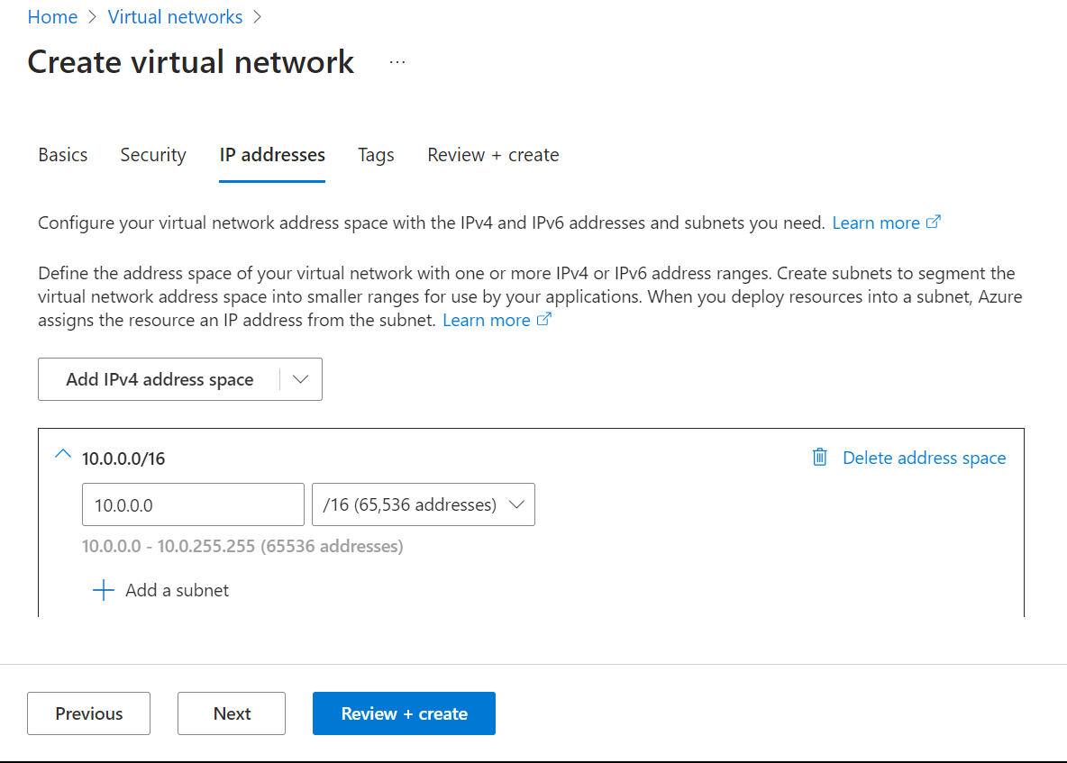

Step 3: Create Virtual Machine: Server1🡪Region: Central India🡪Image:Ubuntu Sever

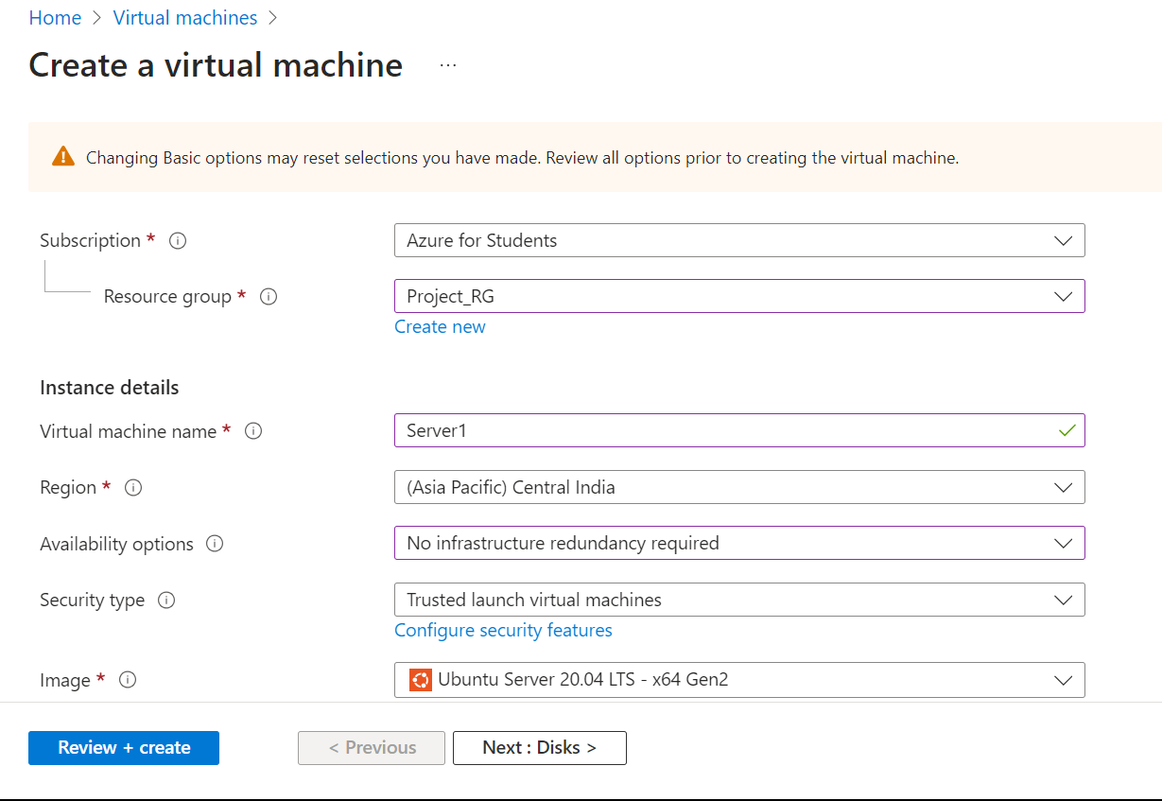

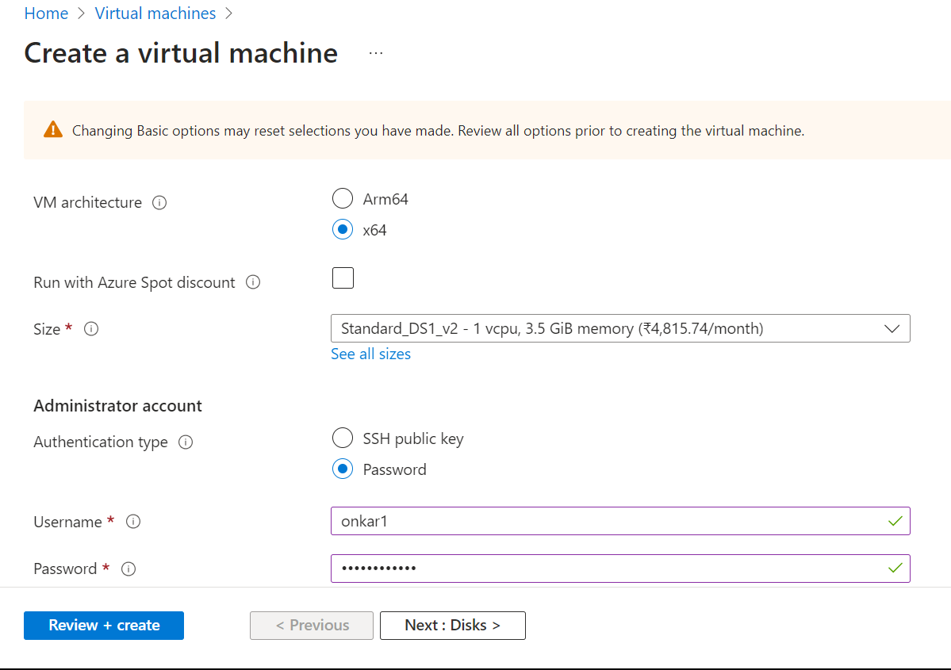

Step 4: Create Virtual Machine: Server2🡪Region: Central India🡪Image:Ubuntu Sever

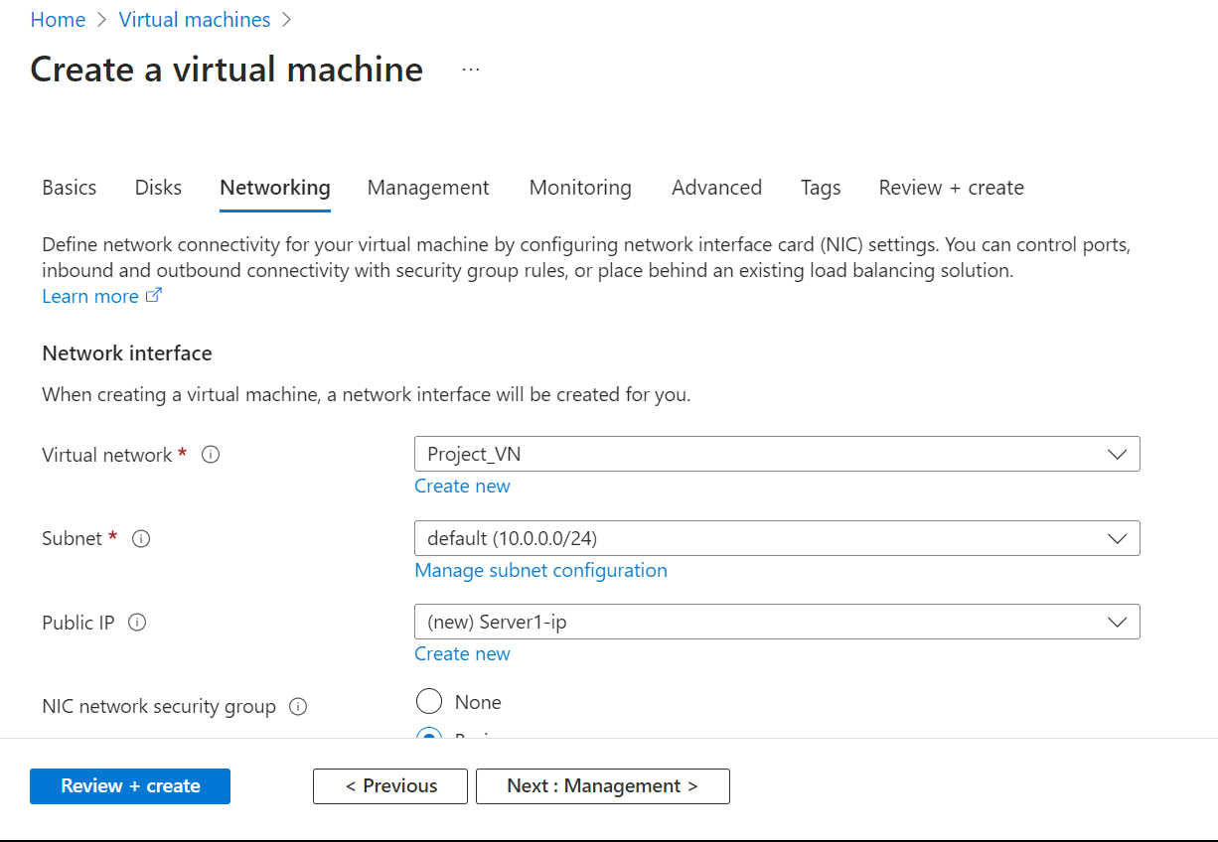

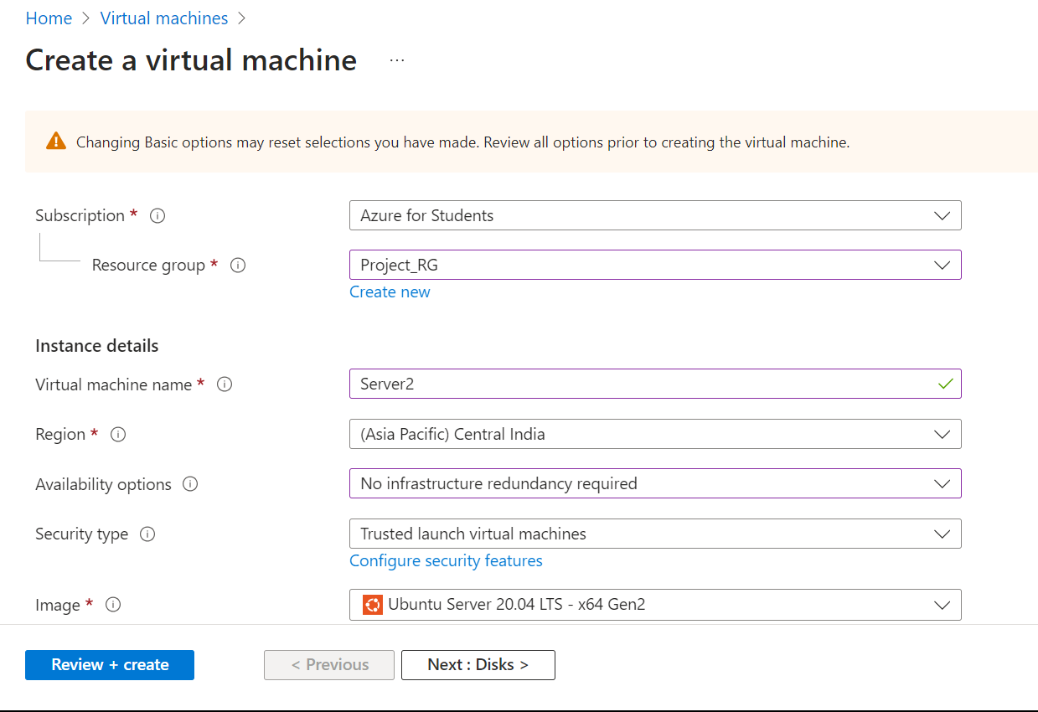

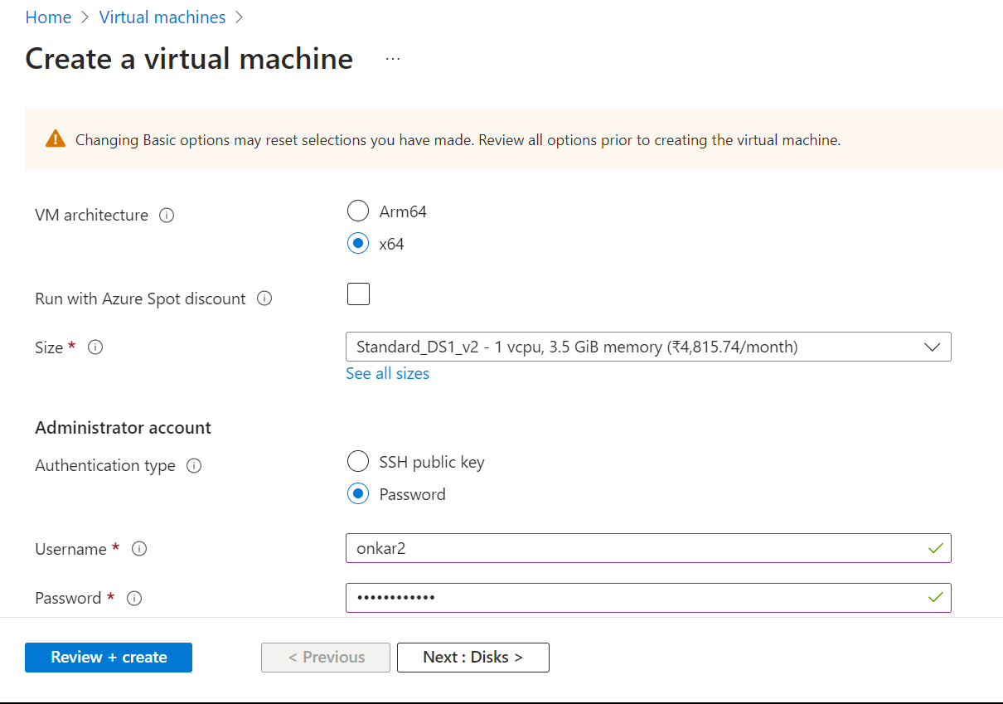

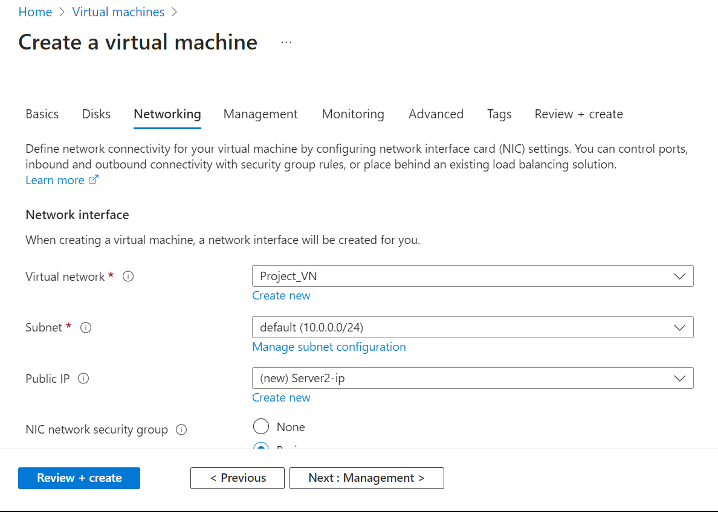

Step 5: Open Putty🡪Connect Server1 with Public IP Address

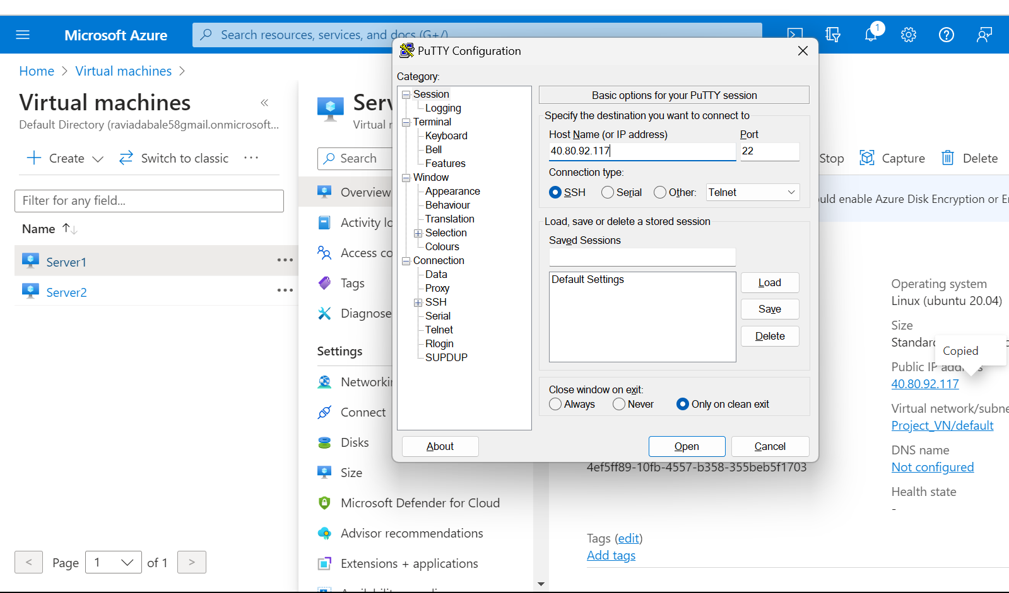

🡪Login as Sever1🡪onkar1🡪Install Apache2 Sever in Server1

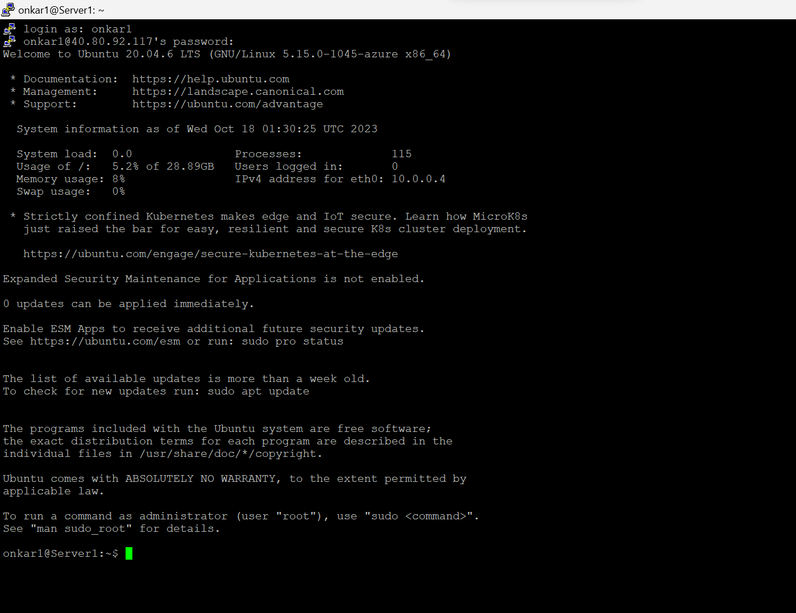



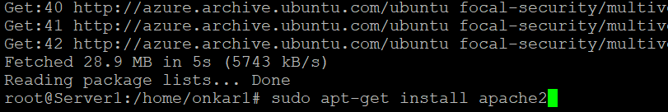

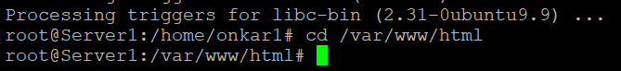

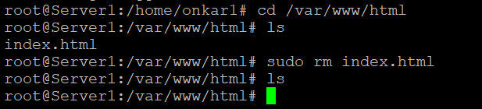





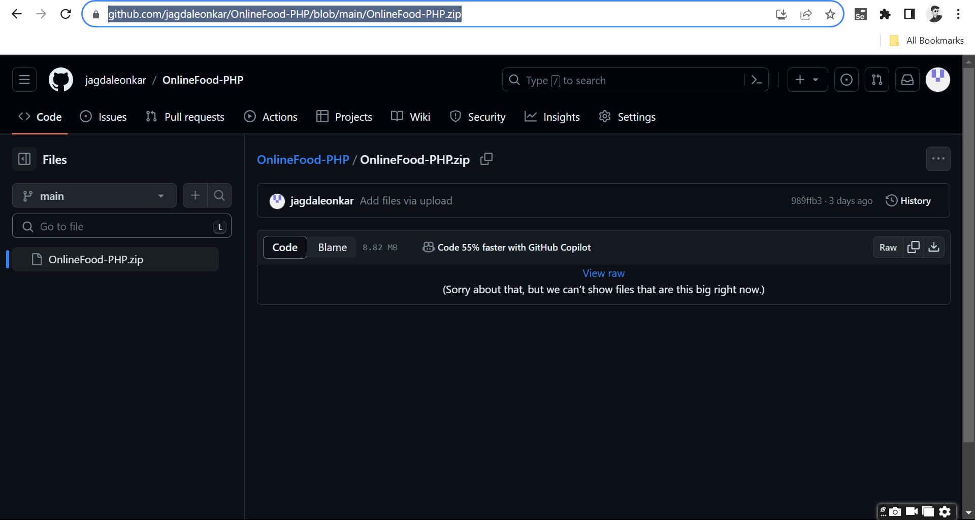

🡪Git Clone🡪OnlineFood-PHP file from Github Repository

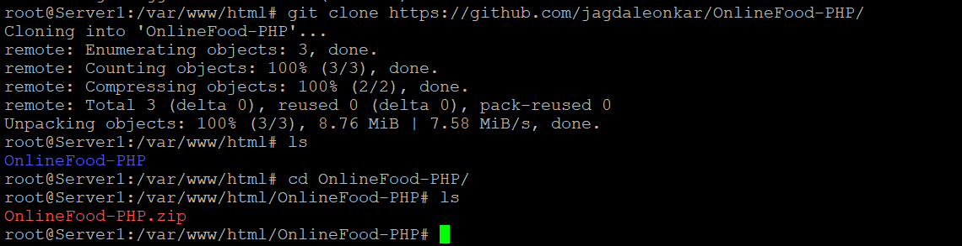

🡪Unzip🡪OnlineFood-PHP.zip File

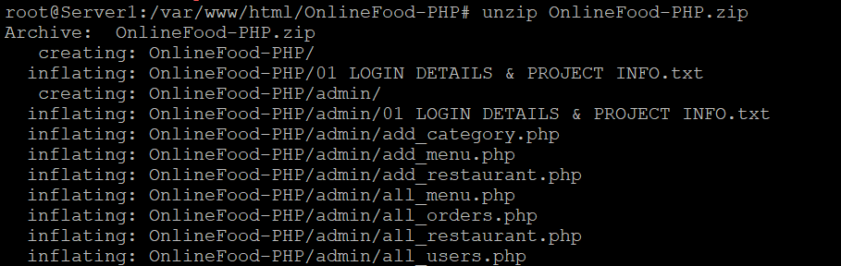

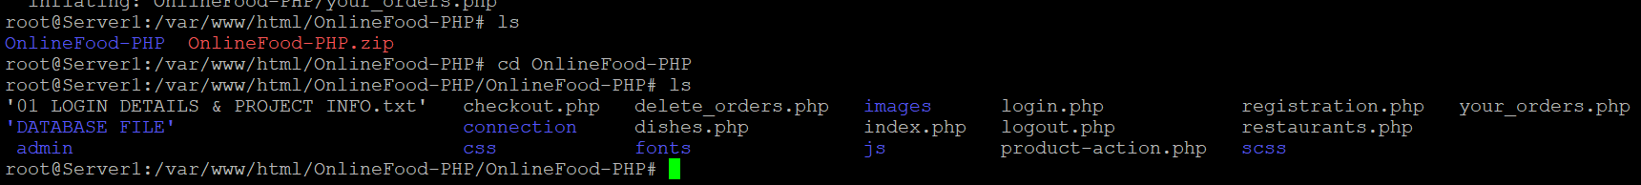

🡪Remove All php files in /var/www/html Directory



Step 6: Open Putty🡪Connect Server2 with Public IP🡪Do the Same Configuration for Server2

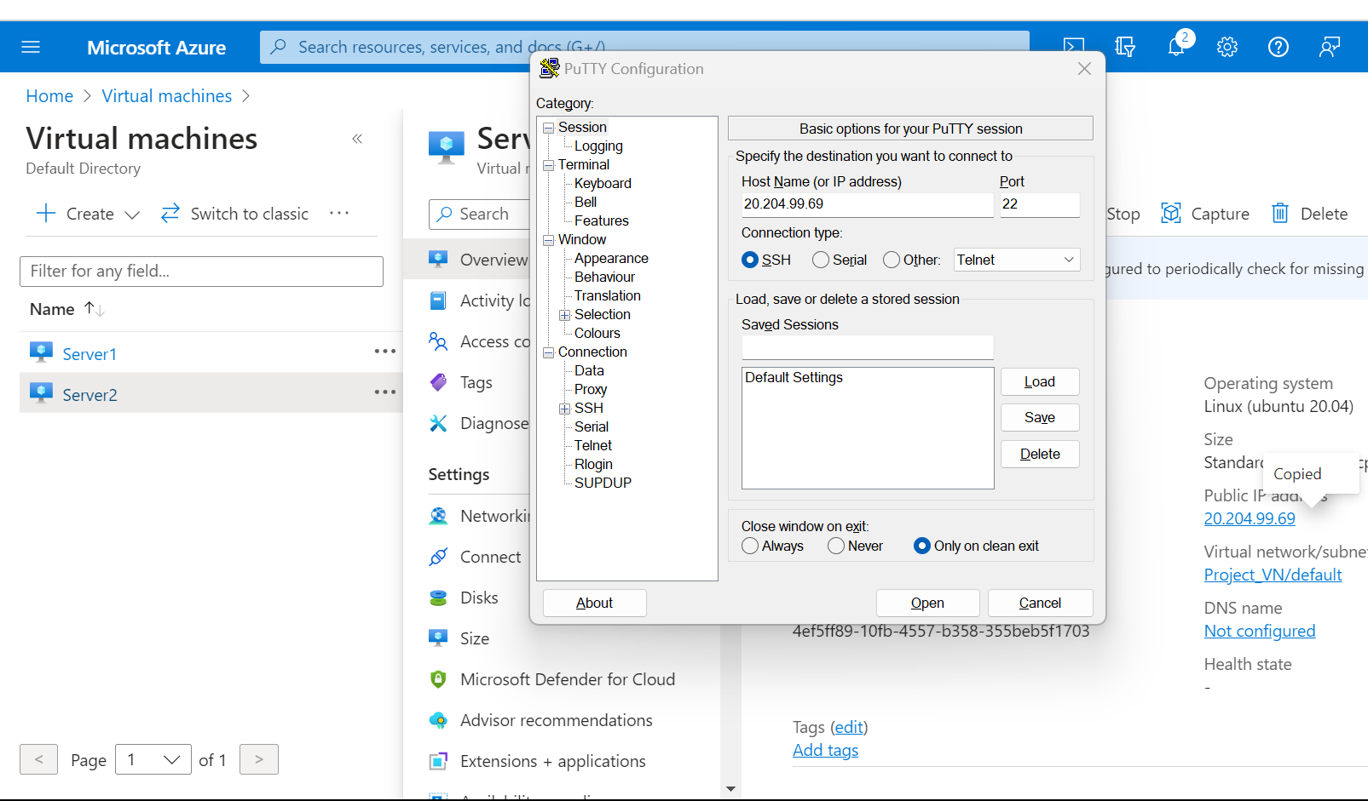

Step 7: Now Connect Database

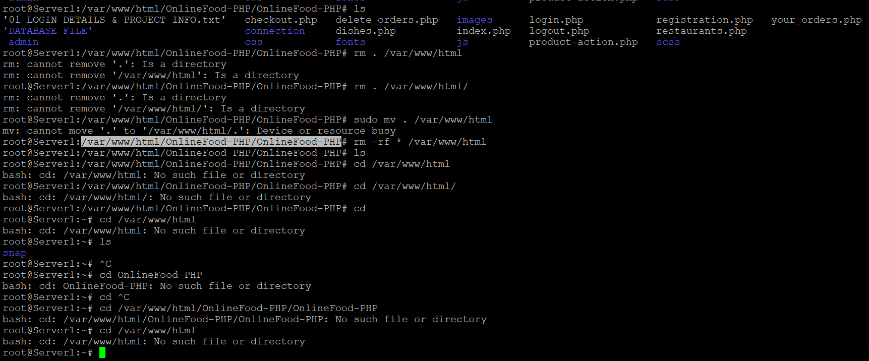

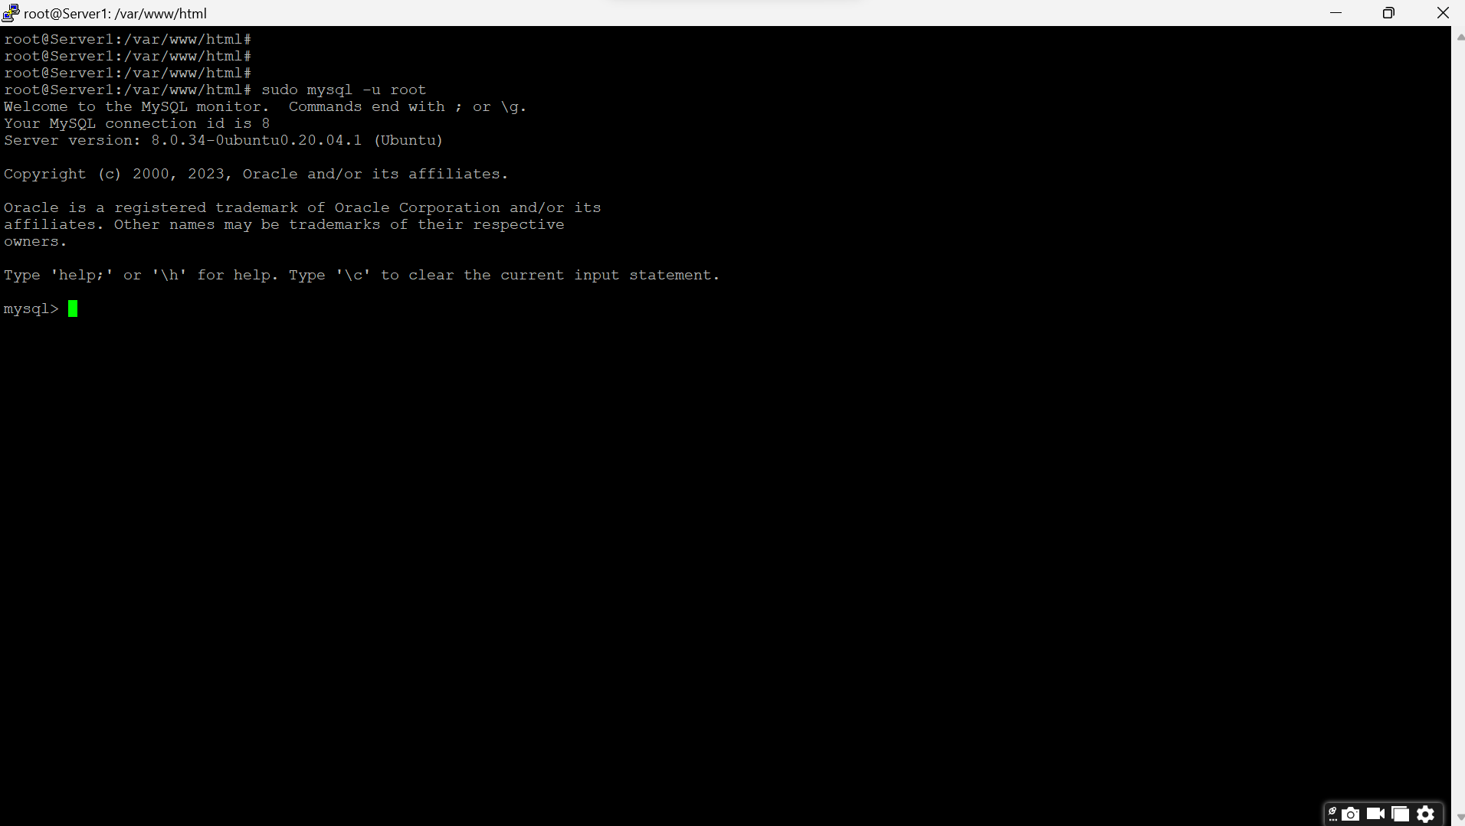

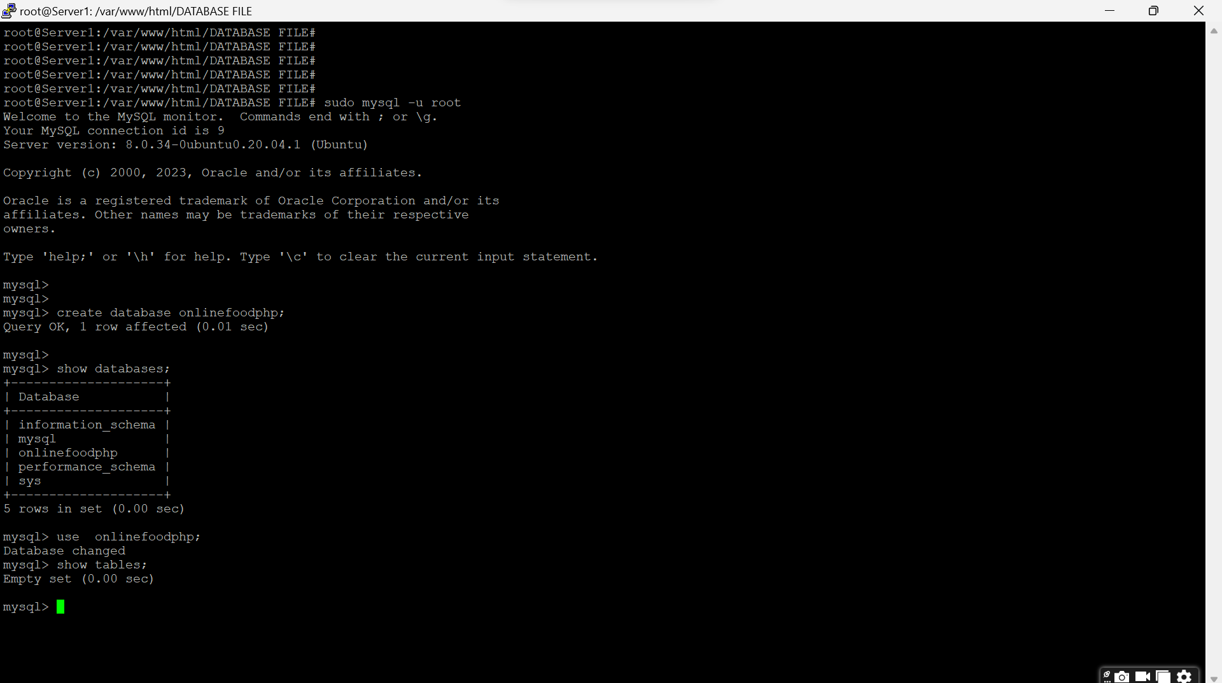

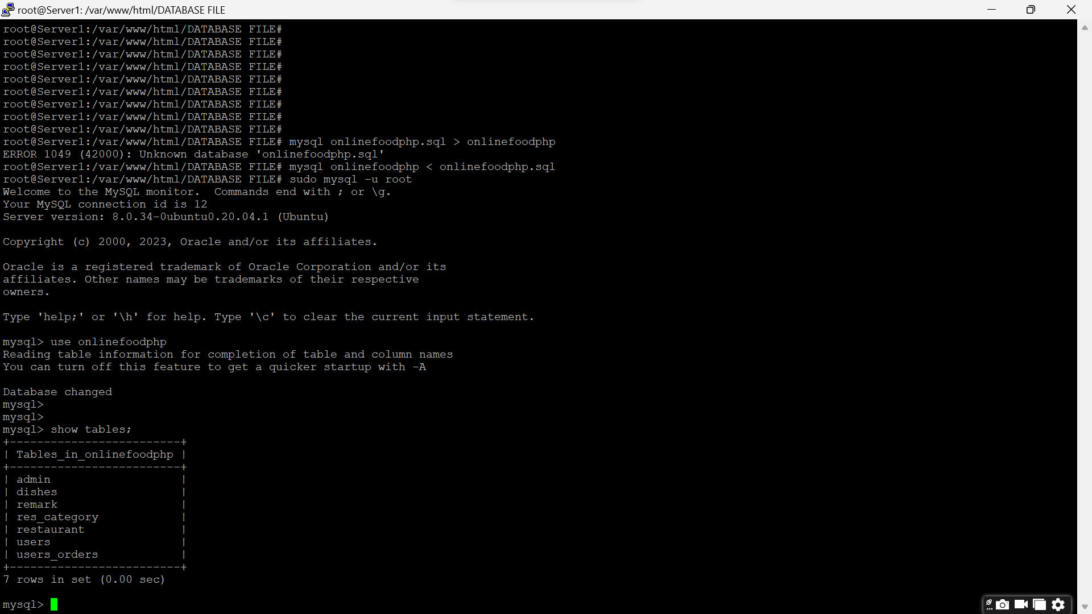

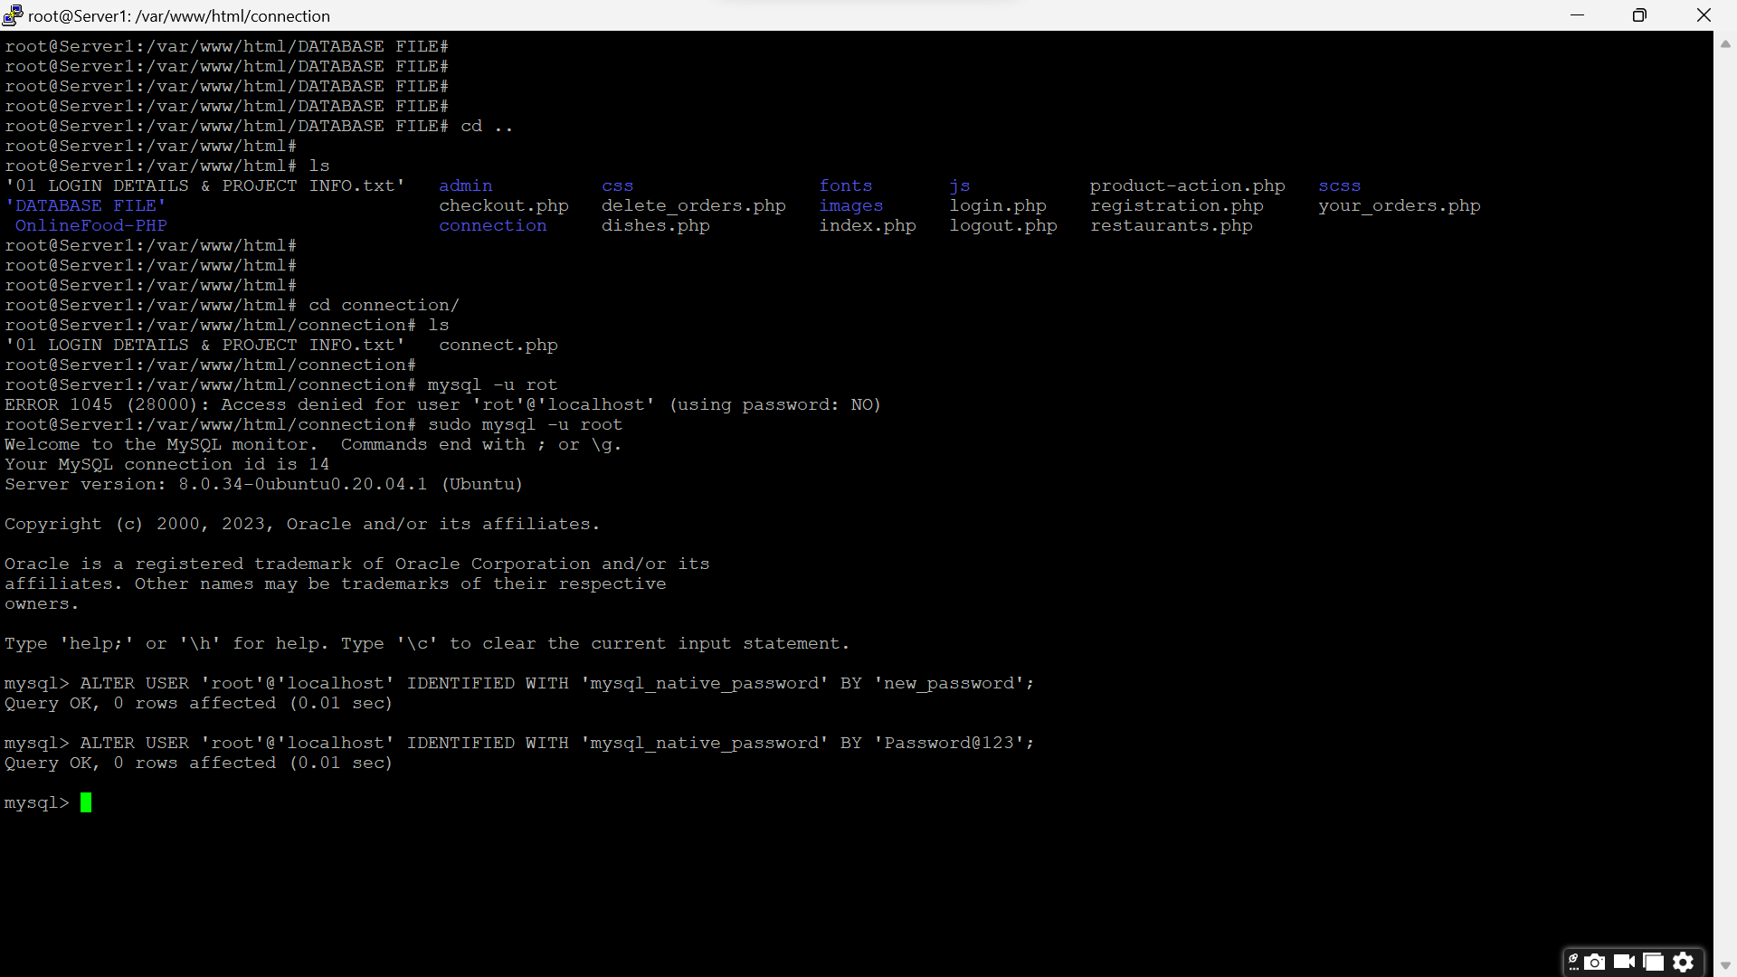

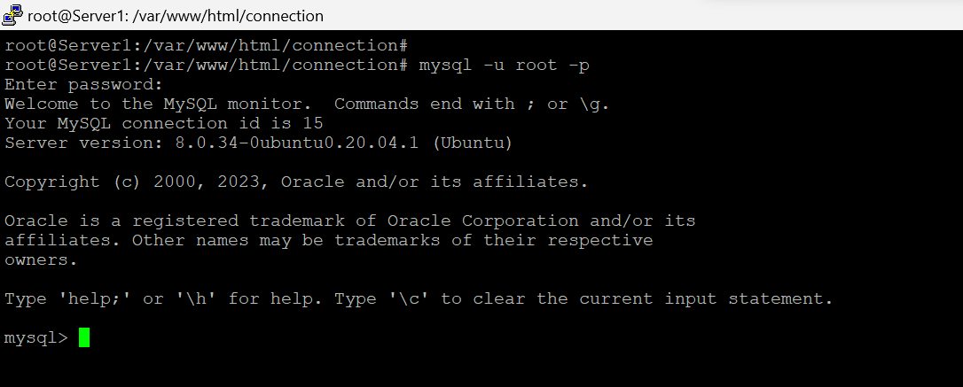

🡪Connect with mysqli

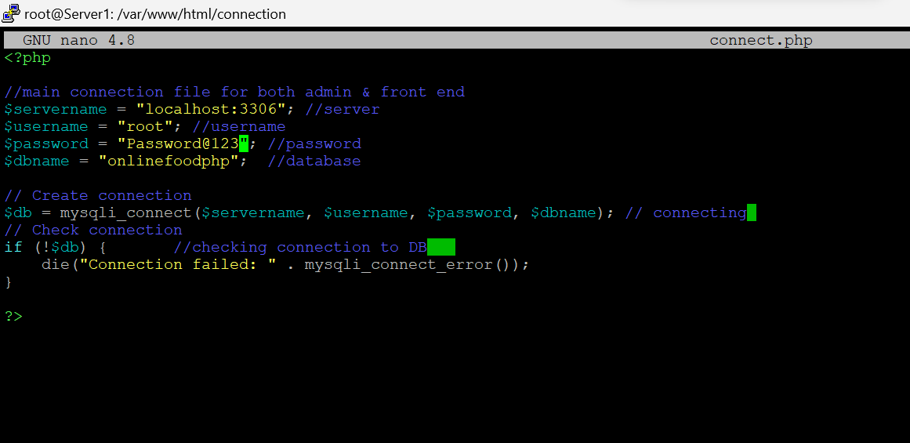

Step 8: Create Traffic Manager

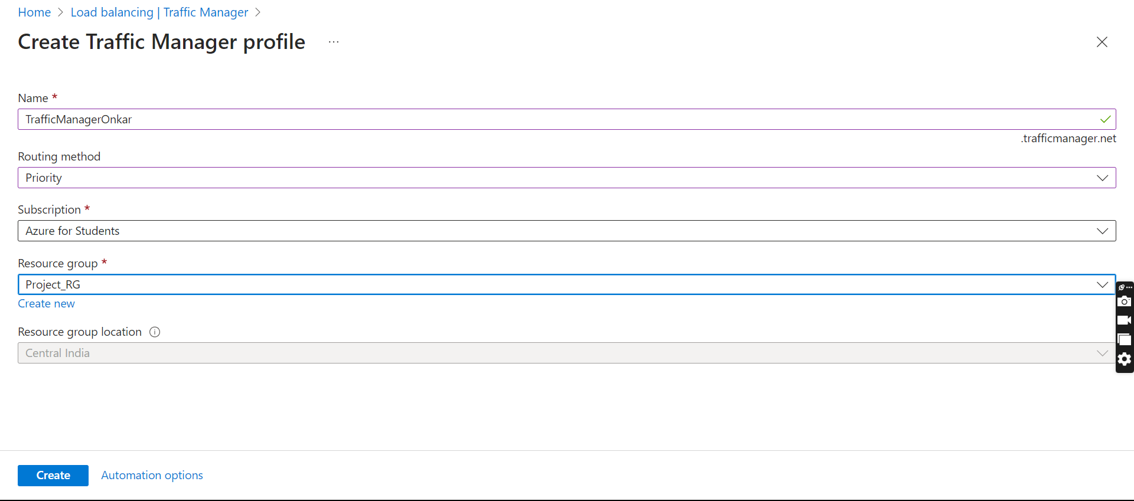

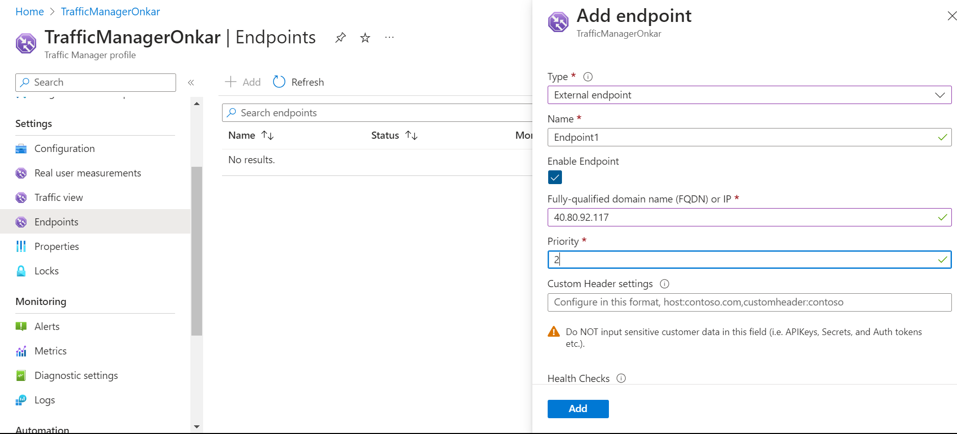

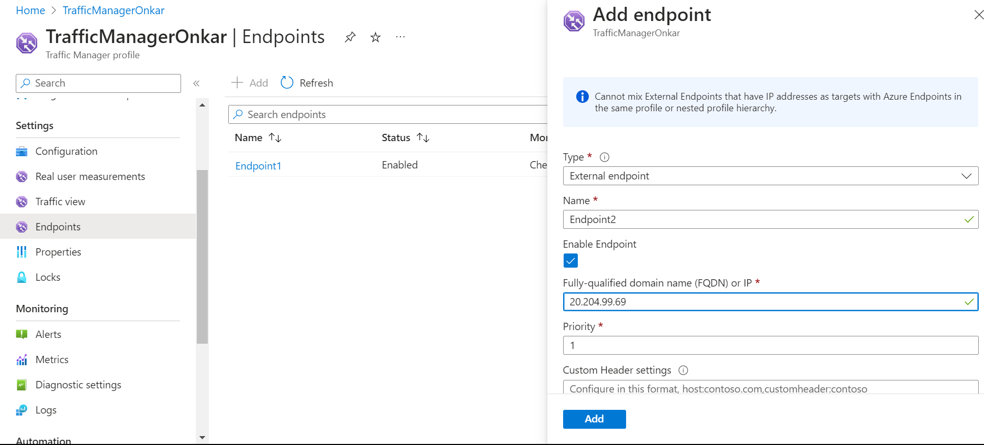

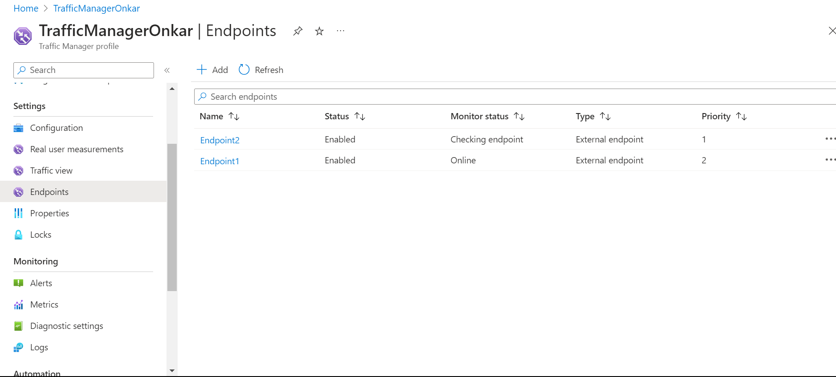

Step 9🡪Create Monitoring Service🡪Alert Rule

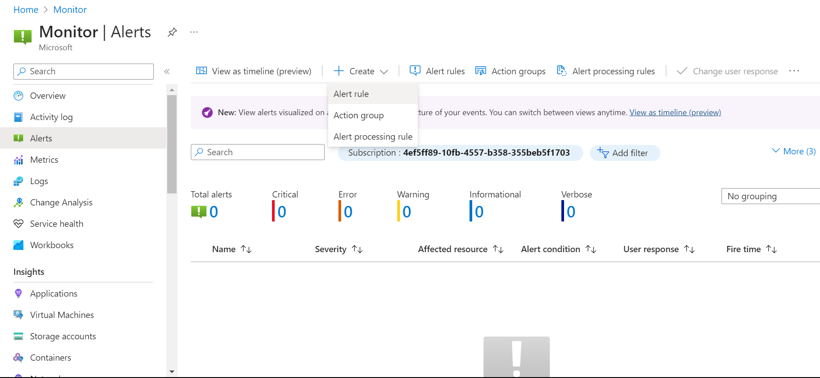

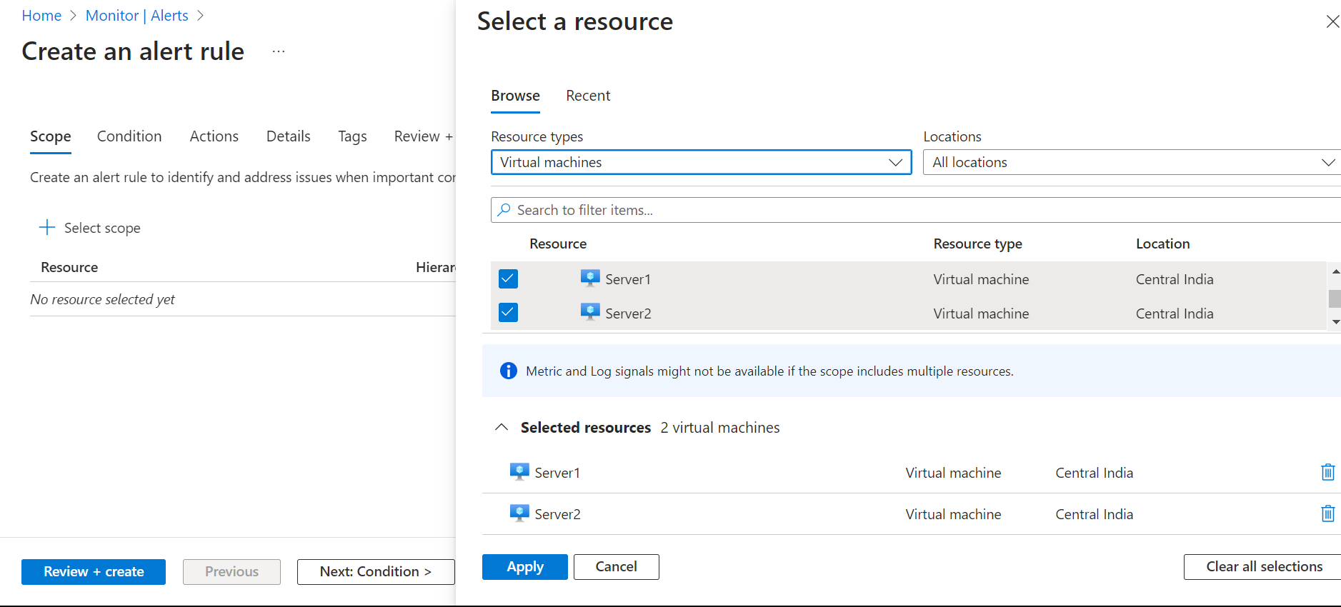

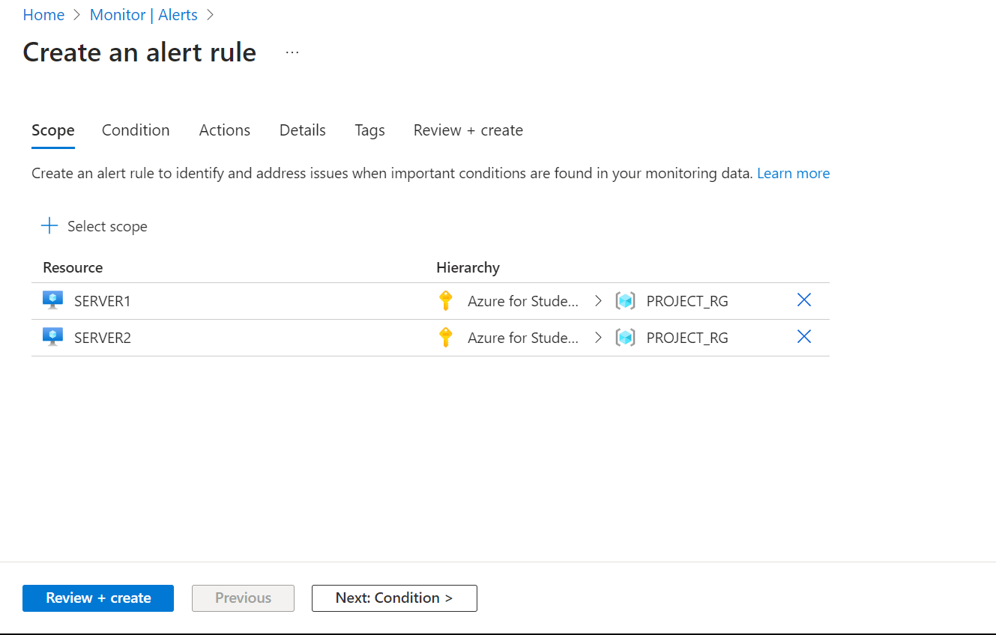

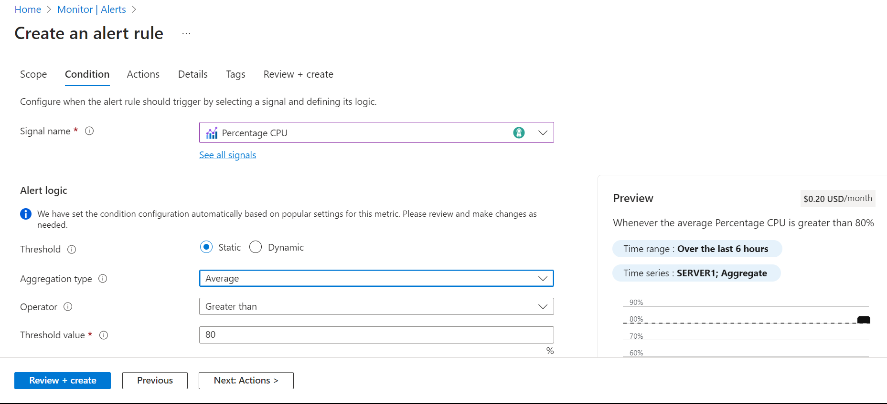

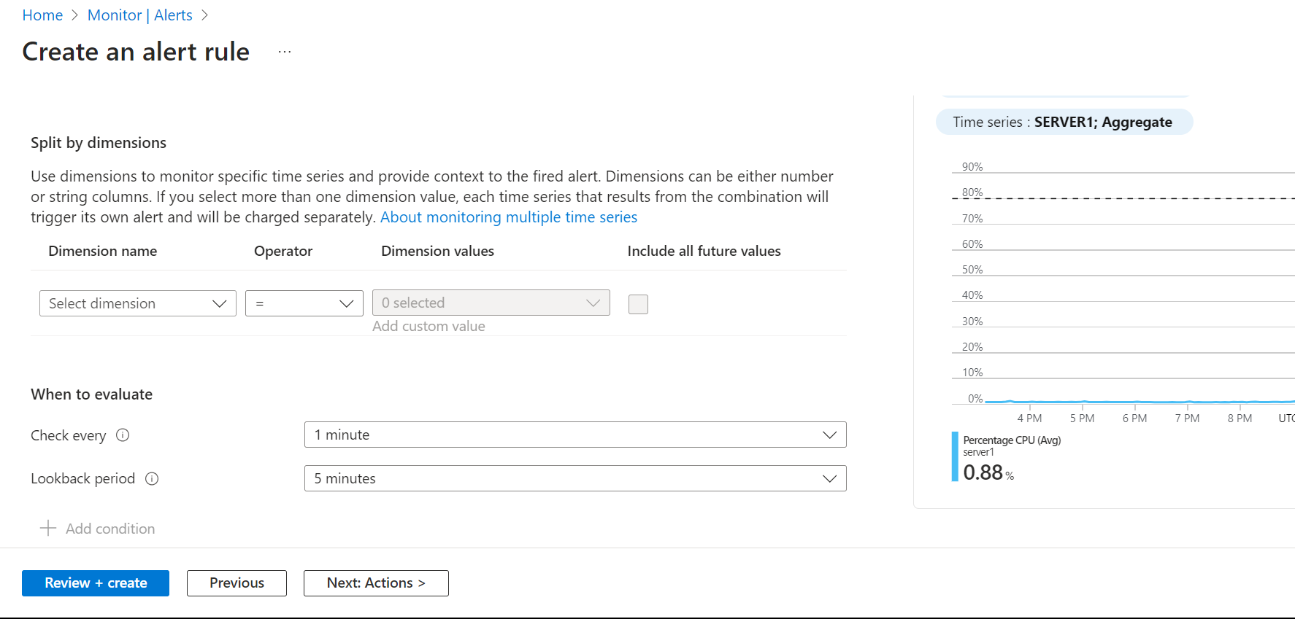

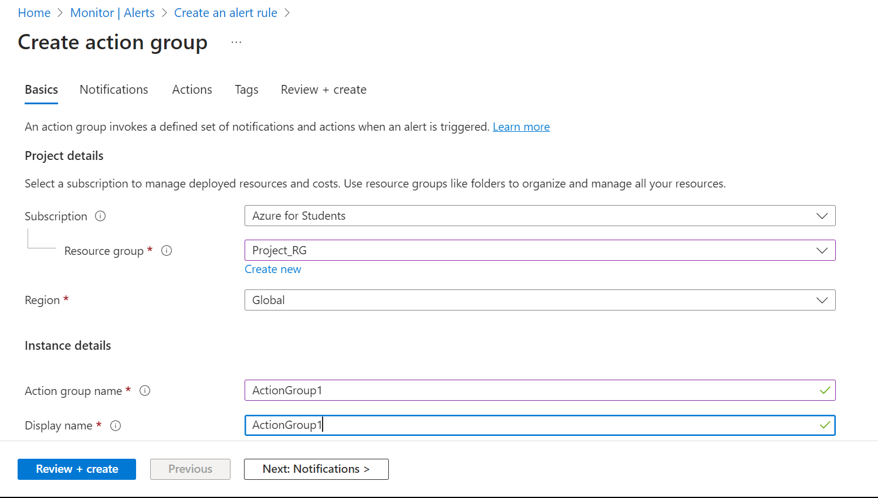

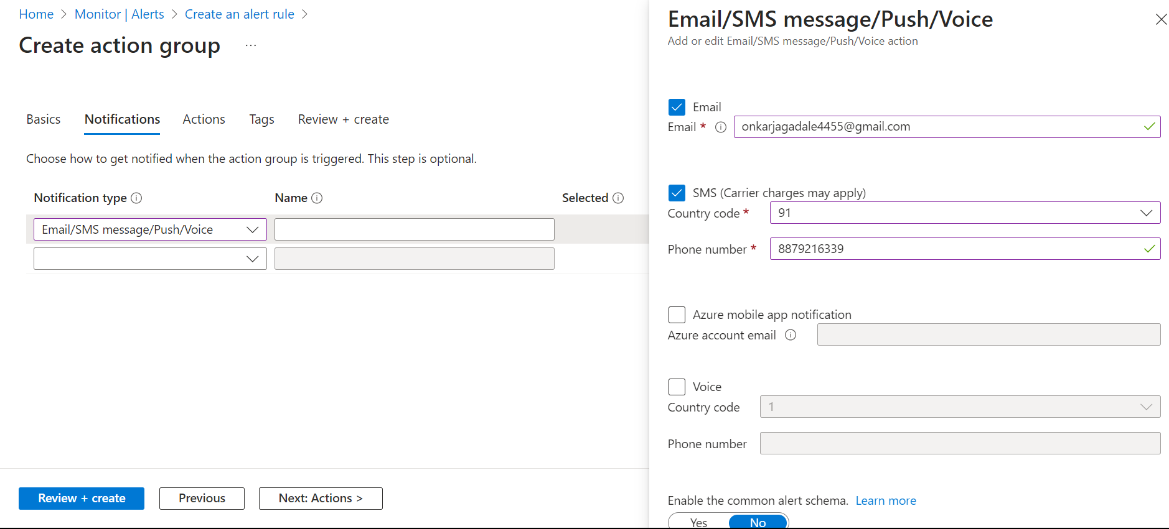

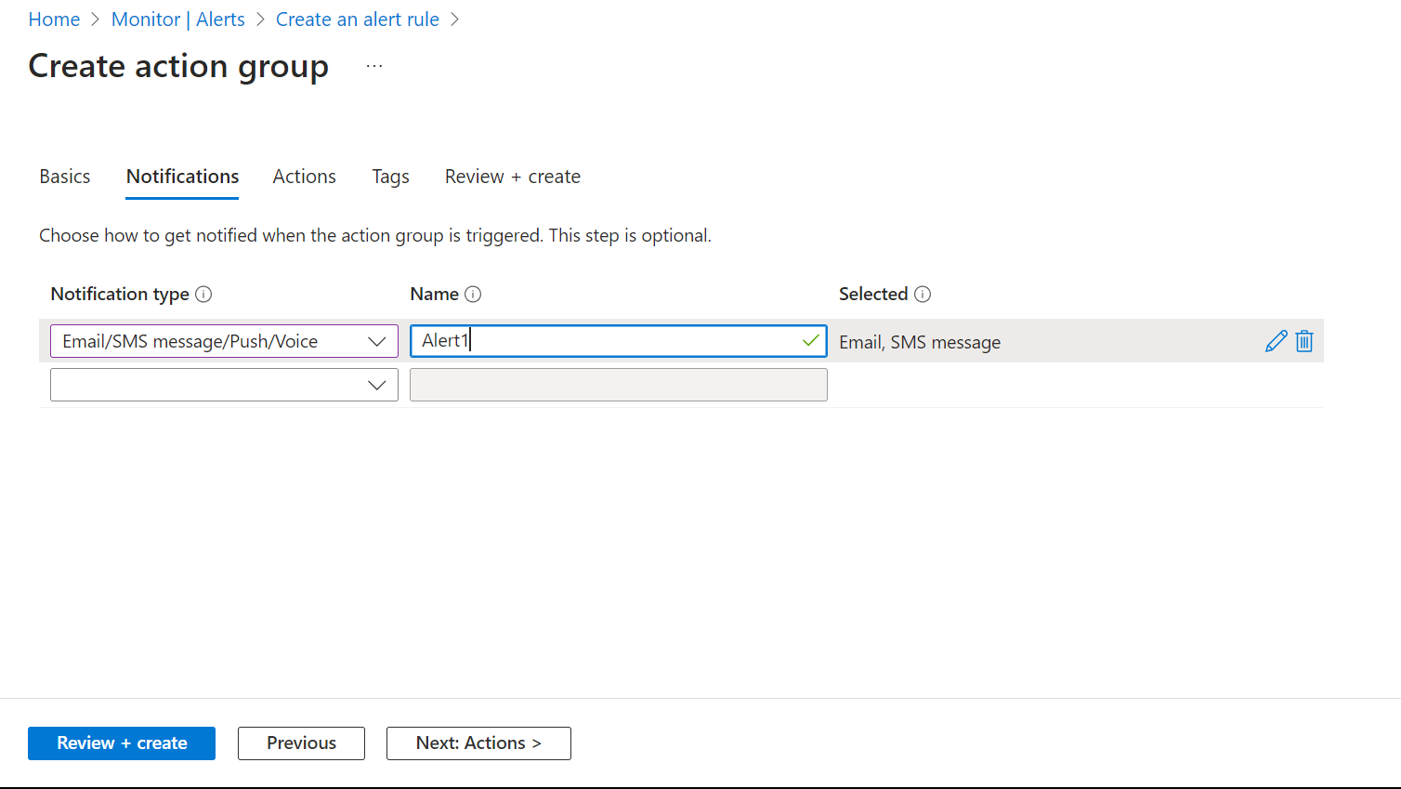

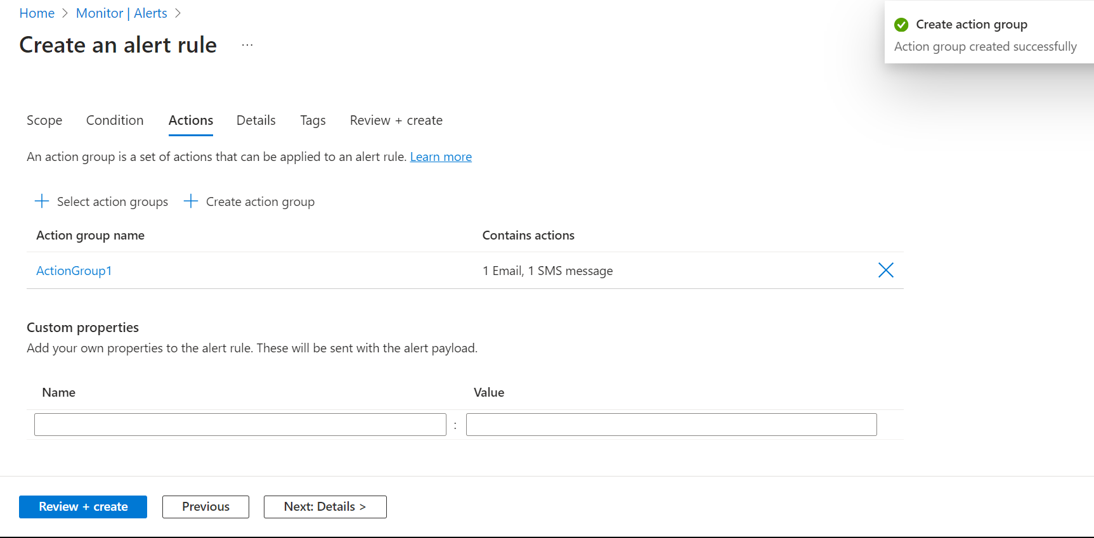

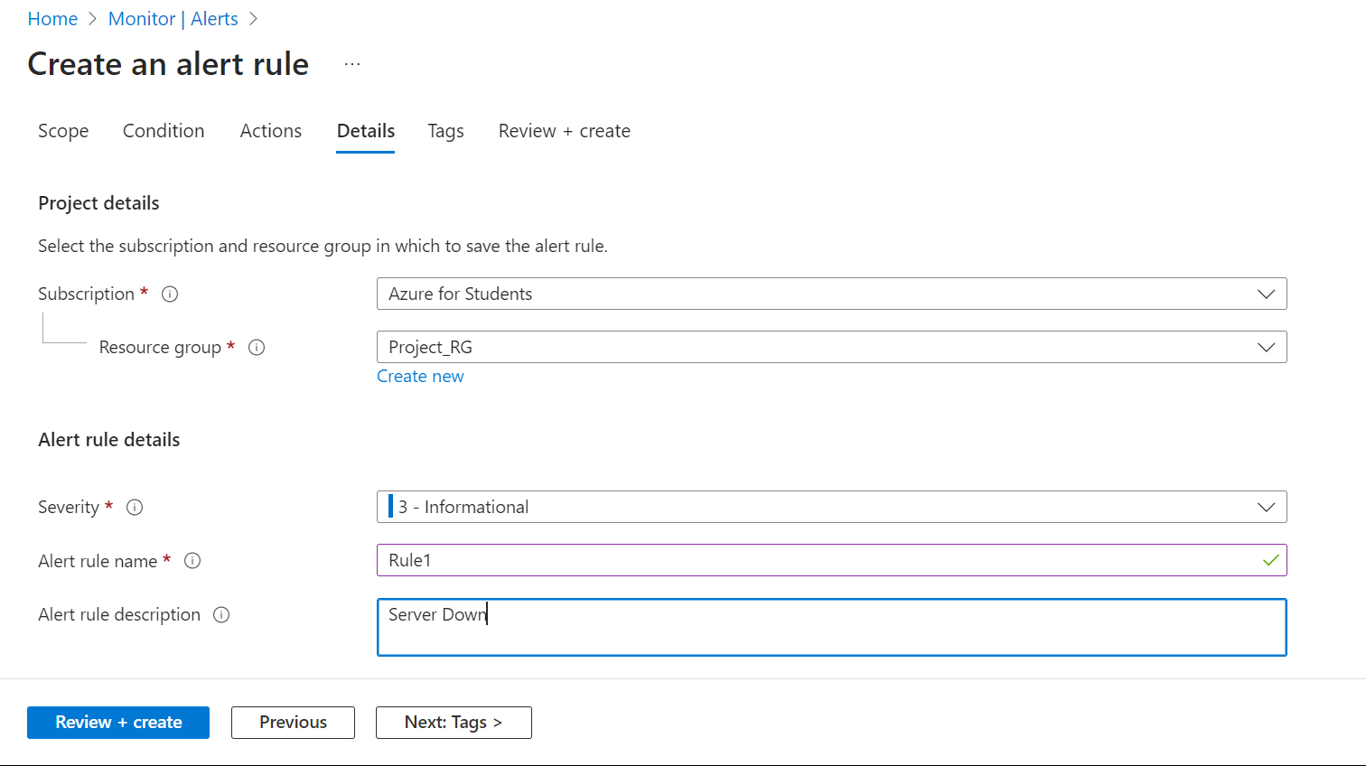

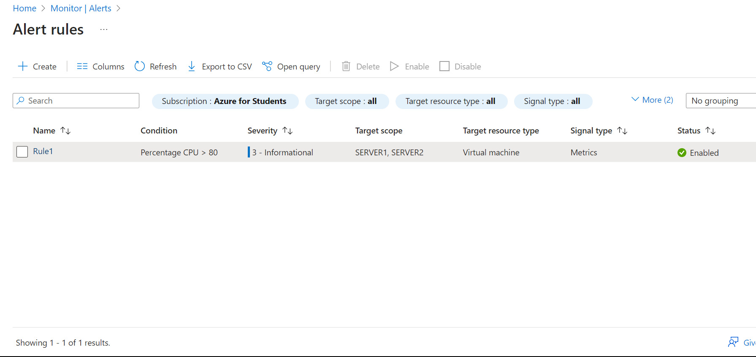

Step 10🡪Create DNS Zones

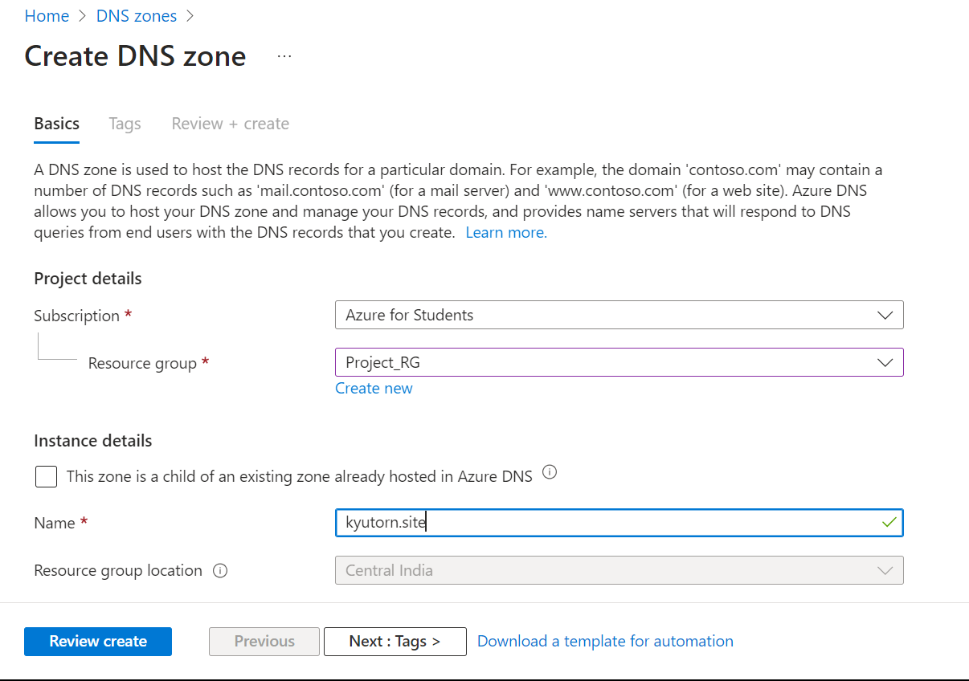

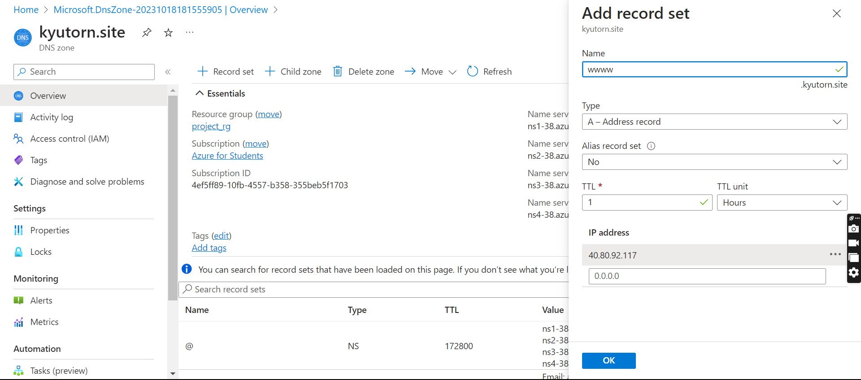

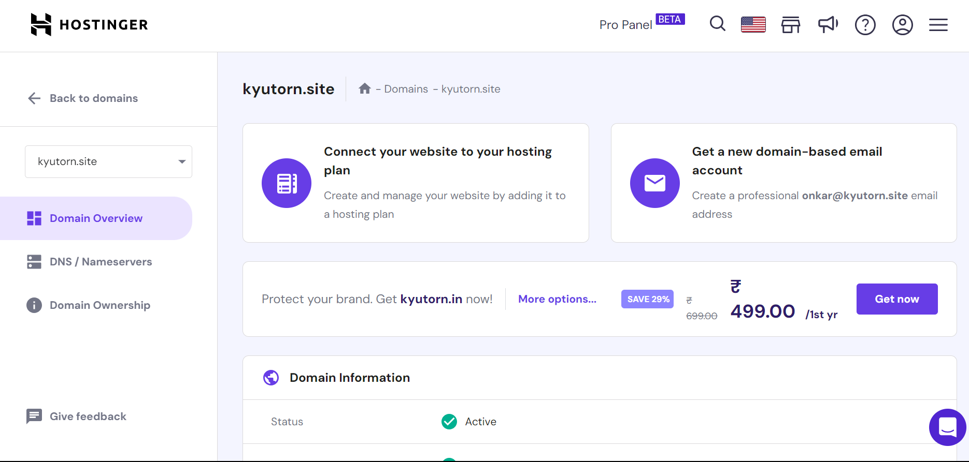

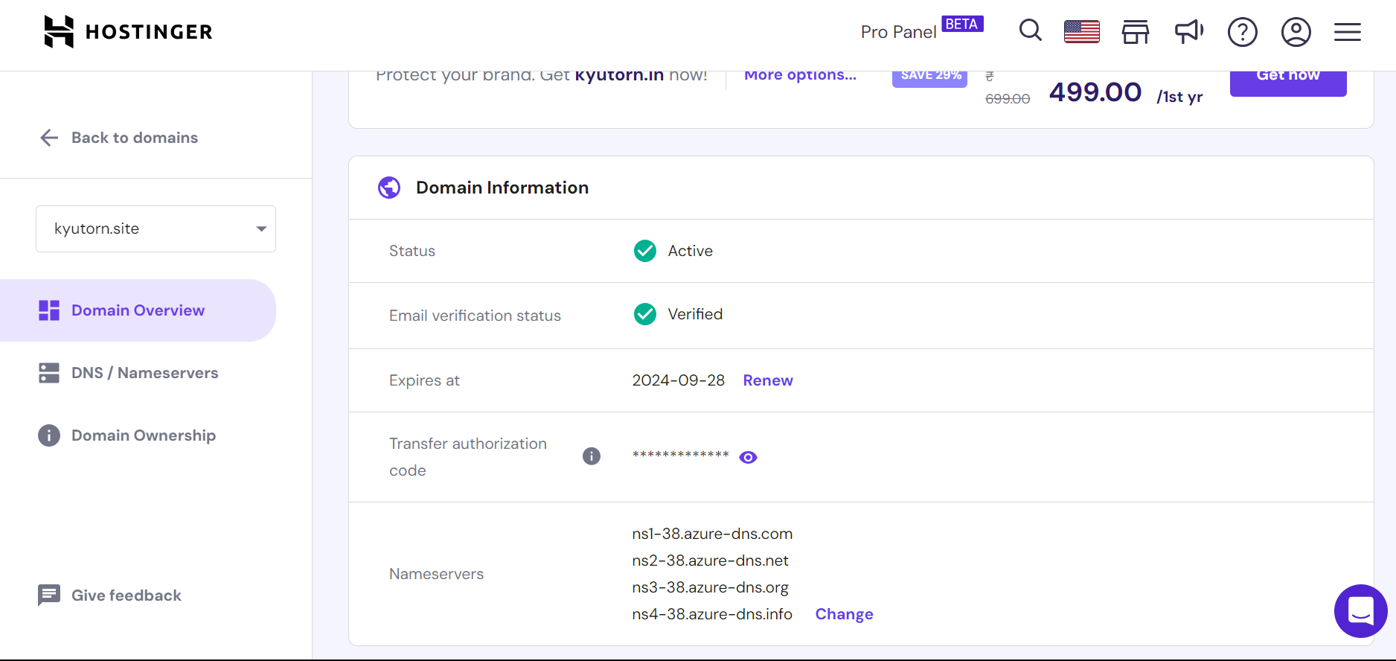

Step 11: First Open Website via IP’s of Server 1 and Sever2

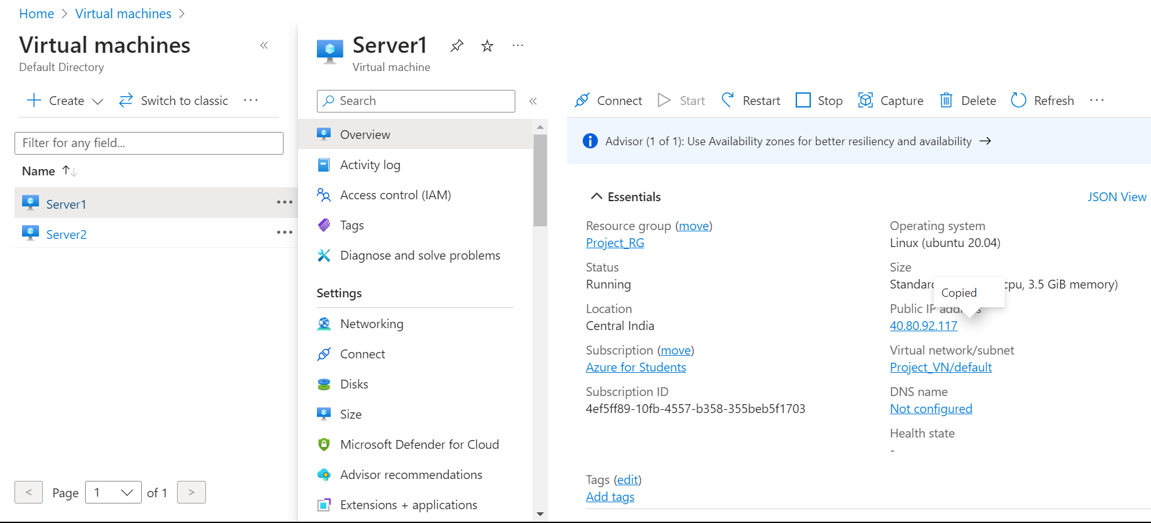

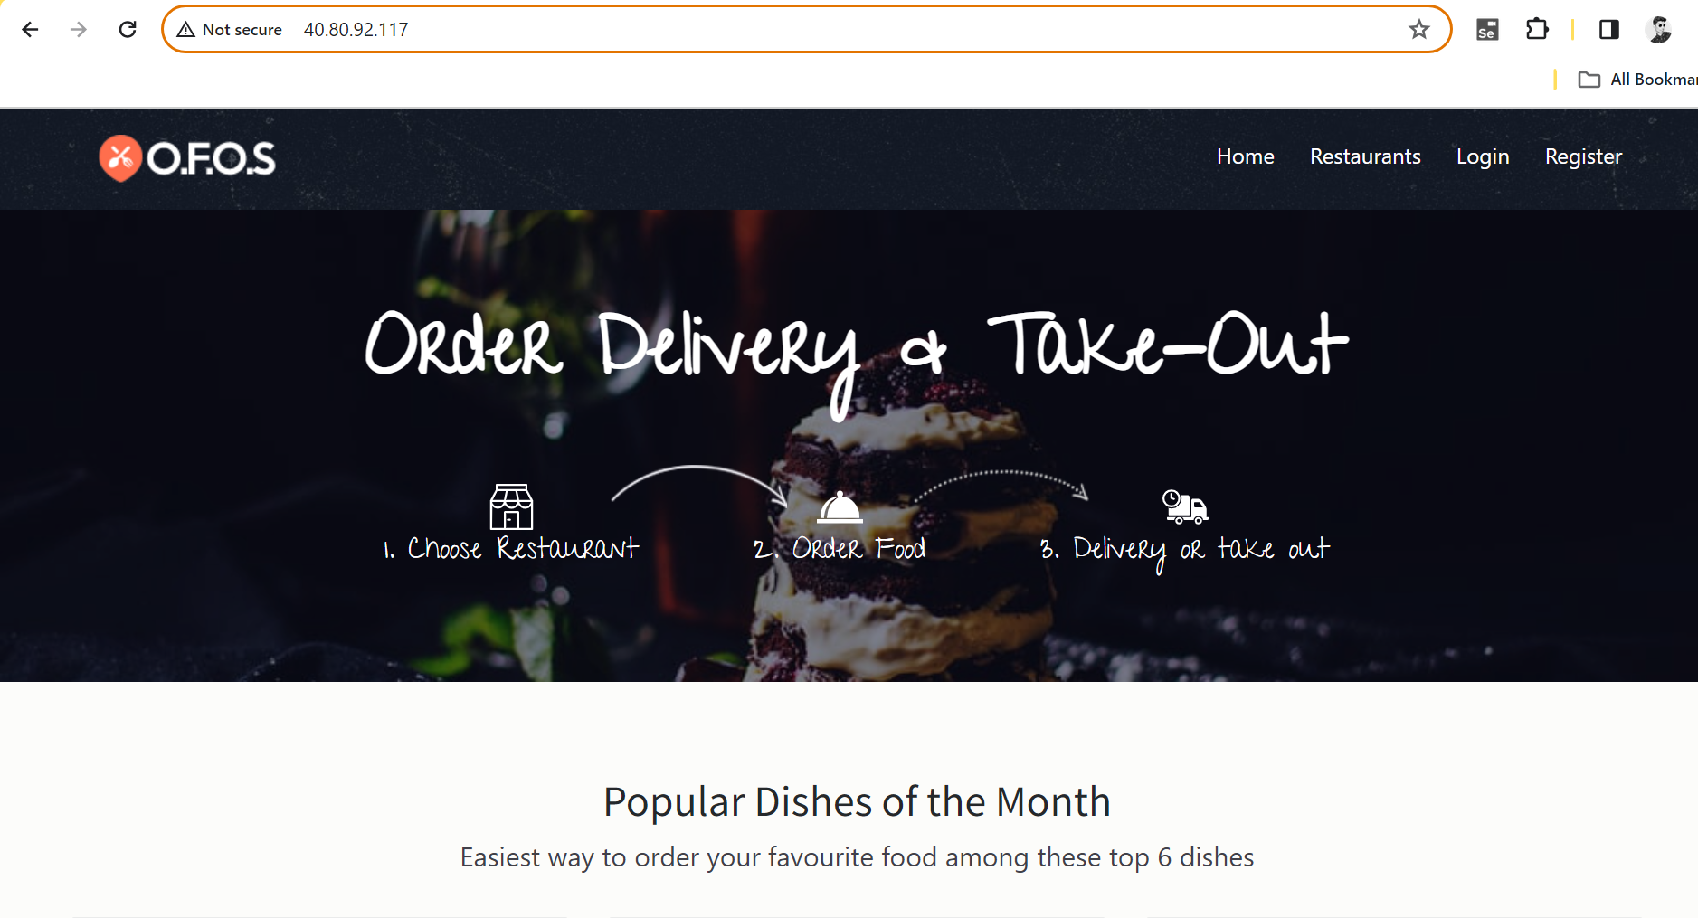

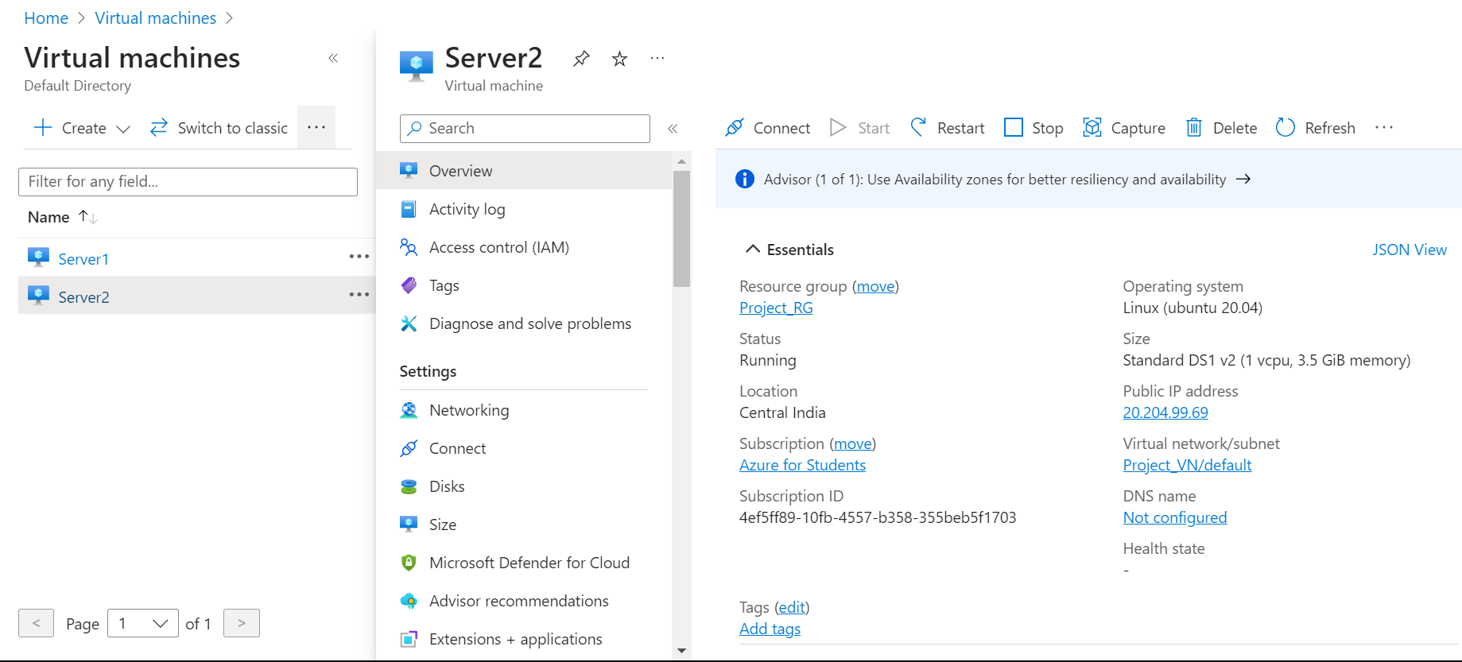

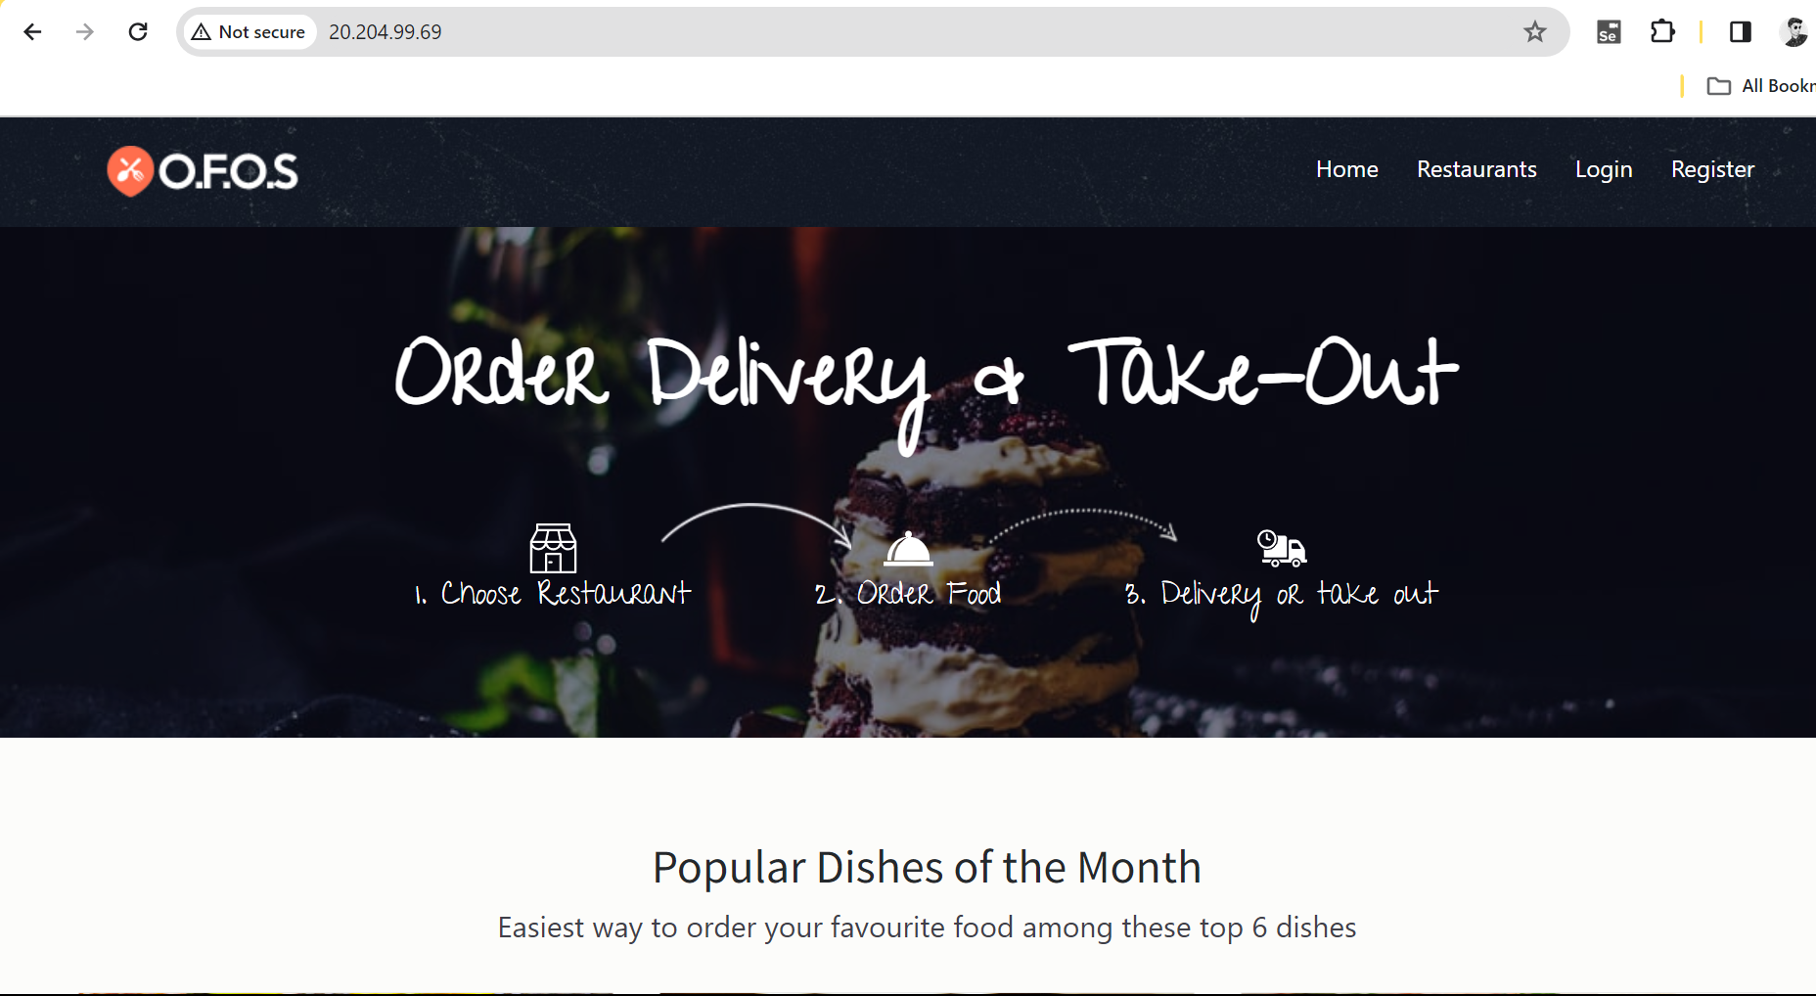

Step 12🡪Open Website via DNS Domain🡪www.kyutorn.site

